What is cloud?

cloud is **the Internet**—more specifically, it's all of the things you can access remotely over the Internet.

The Full form of CLOUD is **Communities and Libraries Online Union Database**

What is Cloud Computing

The term cloud refers to a network or the internet. It is a technology that uses remote servers on the internet to store, manage, and access data online rather than local drives. The data can be anything such as files, images, documents, audio, video, and more.

## Characteristics of Cloud Computing

The characteristics of cloud computing are given below:

**1) Agility**

The cloud **works in a distributed computing environment**. It shares resources among users and works very fast.

**2) High availability and reliability**

The availability of servers is high and more reliable because the **chances of infrastructure failure are minimum**.

**3) High Scalability**

Cloud offers **"on-demand" provisioning of resources on a large scale**, without having engineers for peak loads.

**4) Multi-Sharing**

With the help of cloud computing, **multiple users and applications can work more efficiently** with cost reductions by sharing common infrastructure.

# **Types of Cloud**

There are the following 4 types of cloud that you can deploy according to the organization's needs-

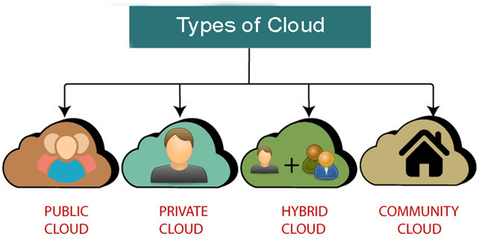

# **Cloud Service Models**

There are the following three types of cloud service models -

1. [Infrastructure as a Service (IaaS)](https://www.javatpoint.com/cloud-service-models#IaaS)
2. [Platform as a Service (PaaS)](https://www.javatpoint.com/cloud-service-models#PaaS)
3. [Software as a Service (SaaS)](https://www.javatpoint.com/cloud-service-models#SaaS)

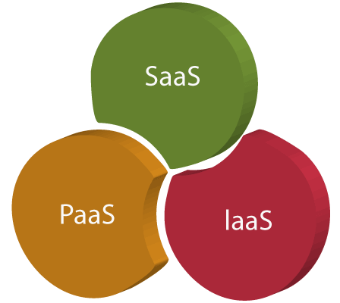

## Infrastructure as a Service (IaaS)

IaaS is also known as **Hardware as a Service (HaaS)**. It is a computing infrastructure managed over the internet. The main advantage of using IaaS is that it helps users to avoid the cost and complexity of purchasing and managing the physical servers.

### **Characteristics of IaaS**

There are the following characteristics of IaaS -

* Resources are available as a service
* Services are highly scalable
* Dynamic and flexible
* GUI and API-based access
* Automated administrative tasks

**Example:** DigitalOcean, Linode, Amazon Web Services (AWS), Microsoft Azure, Google Compute Engine (GCE), Rackspace, and Cisco Metacloud.

To know more about the IaaS, [**click here**](https://www.javatpoint.com/infrastructure-as-a-service).

## Platform as a Service (PaaS)

PaaS cloud computing platform is created for the programmer to develop, test, run, and manage the applications.

### **Characteristics of PaaS**

There are the following characteristics of PaaS -

* Accessible to various users via the same development application.
* Integrates with web services and databases.
* Builds on virtualization technology, so resources can easily be scaled up or down as per the organization's need.
* Support multiple languages and frameworks.
* Provides an ability to "**Auto-scale**".

**Example:** AWS Elastic Beanstalk, Windows Azure, Heroku, Force.com, Google App Engine, Apache Stratos, Magento Commerce Cloud, and OpenShift.

To know more about PaaS, [click here](https://www.javatpoint.com/platform-as-a-service).

## Software as a Service (SaaS)

SaaS is also known as "**on-demand software**". It is a software in which the applications are hosted by a cloud service provider. Users can access these applications with the help of internet connection and web browser.

### **Characteristics of SaaS**

There are the following characteristics of SaaS -

* Managed from a central location
* Hosted on a remote server
* Accessible over the internet
* Users are not responsible for hardware and software updates. Updates are applied automatically.
* The services are purchased on the pay-as-per-use basis

**Example:** BigCommerce, Google Apps, Salesforce, Dropbox, ZenDesk, Cisco WebEx, ZenDesk, Slack, and GoToMeeting.

## Difference between IaaS, PaaS, and SaaS

The below table shows the difference between IaaS, PaaS, and SaaS -

|  |  |  |
| --- | --- | --- |
| **IaaS** | **Paas** | **SaaS** |
| It provides a virtual data center to store information and create platforms for app development, testing, and deployment. | It provides virtual platforms and tools to create, test, and deploy apps. | It provides web software and apps to complete business tasks. |
| It provides access to resources such as virtual machines, virtual storage, etc. | It provides runtime environments and deployment tools for applications. | It provides software as a service to the end-users. |
| It is used by network architects. | It is used by developers. | It is used by end users. |
| IaaS provides only Infrastructure. | PaaS provides Infrastructure+Platform. | SaaS provides Infrastructure+Platform +Software. |